Microclimate Assessment Sheet

Where could we locate new facilities around the school to take best advantage of the school’s microclimate?

Group task: Pupils to work together to use the data collected within the microclimate investigation to put together a bid to present to the Head for some funding to locate some new facilities. These could be benches, solar panels, turbines, bins, specific plants.

This is a group task where the production and presenting of the work should be equally shared out within the group.
Groups are to be between 2-4 persons.
You will have a maximum of 6 PowerPoint slides to present your ideas.
You will have a maximum of 3 minutes to present your ideas.
You will be assessed by the teacher and peer assessed by your class on the contents of your presentation:
- Do you present your ideas clearly?
  - What is the proposal?
  - Have you used the data well?
  - Does your location link to the data?
- Are your slides appropriate to the task?
  - Do you include data from the investigation in an appropriate form
- Are all members of the group involved?
- Have you kept to the time?
- Have you kept to the number of slides?

HOW TO GET GREAT GRADES on Microclimate project
Use these descriptions to help you achieve great grades for your written work!

GRADE A*
- Consistently show excellent knowledge, understanding of what the location of the given facility should be
- Presents confidently to the class their ideas.
- Complete tasks with flair!
- Do some independent work or go beyond instructions on some tasks and pursue your own interests and ideas.
- Works well as a team to produce and present their findings
GRADE A
- Achieve virtually all the tasks you are set.
- Show your clear understanding of key ideas to do with the microclimate task and what the location of the facility should be there.
- Complete your written work to a consistently high/very good standard.
- Use good geographical vocabulary, especially new words.
- Show very good geographical knowledge
- Works well as a team to produce and present their findings
GRADE B
- Achieve vast majority of the task you are set
- Show sound understanding of the location of your given facility.
- Complete your written work to a consistently good standard.
- Sound use of geographical vocabulary.
GRADE C
- Attempts the key task, but parts may be incomplete, inconsistent standard of work.
- Complete much work in a sound or reasonable but some work might lack quality or detail.
- Use some geographical vocabulary.
- The group has not worked as a team to produce and present their findings

GRADE D- or U
- Overall, your written work is poor, you haven’t completed enough to show an understanding of how the microclimate data can be used within decision making.
- Only some basic geographical vocabulary, many skills poorly complete obvious gaps in knowledge.
- The group has not worked as a team to produce and present their findings

THINK! What grade would YOU give YOUR work?
Use these descriptions to help you achieve great grades for your written work!

GRADE | Teacher’s Feedback | Pupil Feedback

Microclimate Assessment Sheet

Where could we locate new facilities around the school to take best advantage of the school’s microclimate?

This is a group task where the production and presenting of the work should be equally shared out within the group.
Groups are to be between 2-4 persons.
You will have a maximum of 6 PowerPoint slides to present your ideas.
You will have a maximum of 3 minutes to present your ideas.
You will be assessed by the teacher and peer assessed by your class on the contents of your presentation:
Score presentations from 5 being excellent, 4 very good, 3 good, 2 poor to 1 being very poor
Group | Do you present your ideas clearly? | Have you used the data well? | Does your location link to the data? | Are your slides appropriate to the task? | Do you include data from the investigation in an appropriate form | Are all members of the group involved? | Have you kept to the time? | Have you kept to the number of slides? | Total Score | COMMENTS

School Microclimate Investigation sheet

Aim: What is the climate of our place/school like? Does it have a microclimate? What is it like?

Hypotheses: Here you write down your prediction with an explanation of why you think it will happen

Hypothesis 1

Hypothesis 2

Method: Here you write down what you did to collect the data
Temperature
Windspeed
Wind direction
Ground surface temperature

Results:
Site | location | Temp | windspeed | wind direction | ground surface temp
1
2
3
4
5
6
7
8
9
10
11
12
13
14
15
16
17
18
19
20
21
22
23
24
25
26
27
28
29
30

Conclusions: This is where you report the findings of your results referring to your hypotheses
Evaluation: This is where you assess your investigation and state whether you could answer the aim and how you could improve your investigation.

Microclimate Investigation instruction sheet

Data Collection:
Data can be either collected via a data collection sheet where pupils go around school and record data with a location then input this data in to a csv file( a type of excel file). This file will need a means of geo referencing the data. For this task you will l need to give each point a latitude longitude value to map it. The lat, long can be found out by using the measure tool covered earlier to locate a point. Click on a location and the latitude and longitude will appear. Copy the co-ordinates into the spreadsheet.
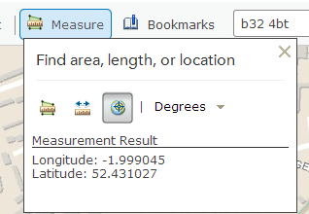

Site | Longitude | Latitude | Temp
1 | -1.99918 | 52.43187 | 3
2 | -1.99909 | 52.4318 | 4
3 | -1.999 | 52.43172 | 4
4 | -1.99887 | 52.43163 | 5
5 | -1.99878 | 52.43167 | 5
6 | -1.99886 | 52.43177 | 3
7 | -1.99893 | 52.43185 | 3

You will need to collect a minimum of 30 locations around school for there to be enough data to carry out some of spatial analysis tools.
The alternative way of collecting data is by using the arc collector app on a mobile device such as a mobile phone or iPad or tablet. This is an app that allows you to collect data in the field with the data uploading directly to a map without the need of loading the map via a spreadsheet. Using this method it is still good practice to also record your data via the spreadsheet method as a back up.

First you will need to download the apps. Do this by going to the following website http://www.arcgis.com/features/apps/index.html or to your apps provider. It can downloaded for both iPhone and android smartphones.
Download the following apps.
- ArcGIS and
- Collector for ArcGIS App
Click on the Collector for ArcGIS app. You will need to log on to the Collector for ArcGIS app by typing the same log in and password as used earlier.
Once opened a list of maps will appear.
The search for the following map the map you’ve created for this task.
Once opened click on collect a new feature. This will open a dialogue box with data to fill in. After each section type next. When you get to the location either touch the map or check if the map has located correctly via GPS then click done. The data has now uploaded to the map.

There is an excellent instruction sheet that ESRIUK has produced that allows you to create the feature that will use in the mobile app that is available via your organisational account. It uses the developer tool that is only available to organisational accounts.

Data Analysis

Go to website http://www.arcgis.com/home/ log in and click on the map tab.
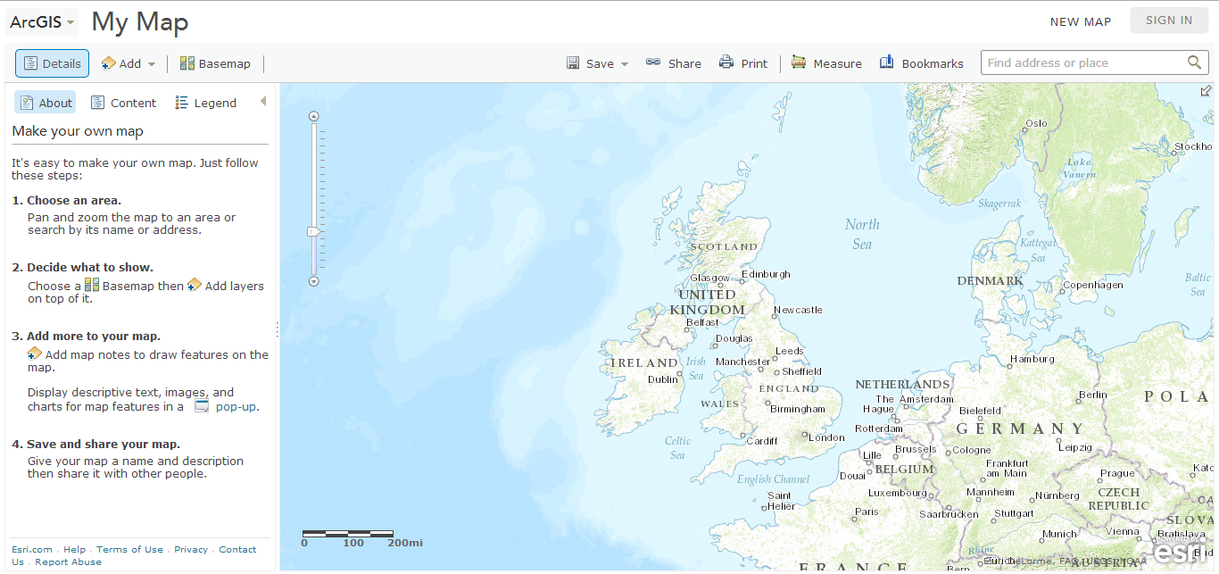
When you save your map, tab found on top of map, you need to give it a name and also some important information including:
Tags , title, summary. Tags are keywords that are used to search maps created.
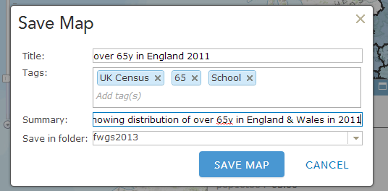
If you want to the change the basemap click on the basemap tap and a variety of basemaps available will appear. Click on the one you want.
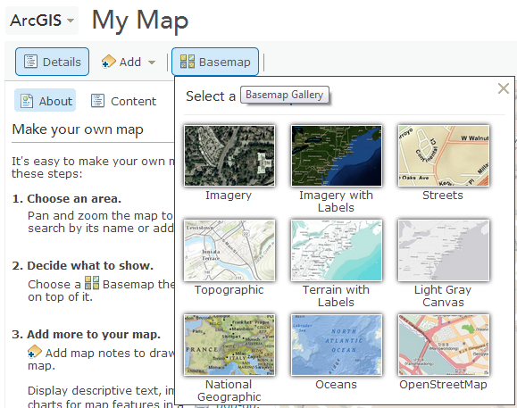

Creating a map using your own data
We are now going to add information created by yourself such as fieldwork data, in this case the wifi data. To this you first need to create an excel spreadsheet where the data you have collected needs to be inputted. This data will need an latitude and longitude X,Y co-ordinate. This has been done for you in the excel CSV file created.
To add data in a spreadsheet go to the add data tab on the top tool bar click add layer from file. Then choose the file you want, in this example its the wifi.CSV then click import layer and the data will load into the map.
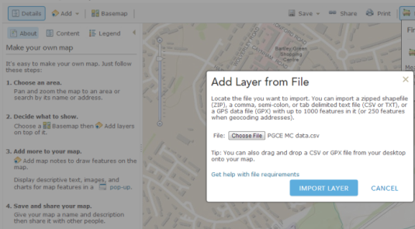
Alternatively you can open the file and drag and drop on to the map and the data will map. When first loaded the data will automatically appear like this below with a change style dialogue box allowing you a variety of ways of showing the information.
If you have added data via the collector app the data should already be loaded in to the map.
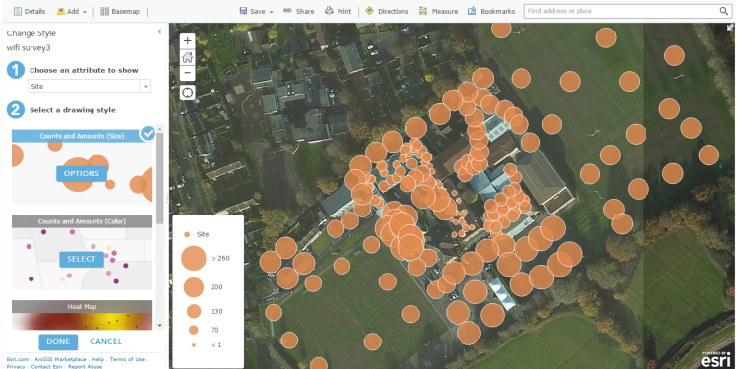
First choose 1. Which attribute you want to show. Here choose a weather variable such as temp. Then choose 2. a drawing style. For this task you have a choice. You could choose counts and amounts or types(unique symbols). For this task you can choose either but counts and amounts is more suitable as you are dealing with changing values. Then click options to change the colour and style as well as when you can see it.
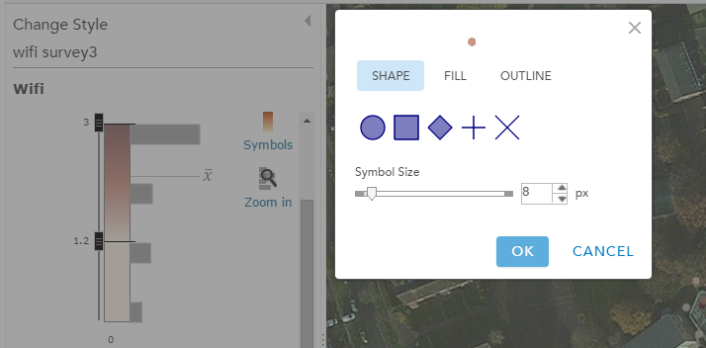
Click fill to change colour range, think here about the background your data is viewed on. Then click ok.
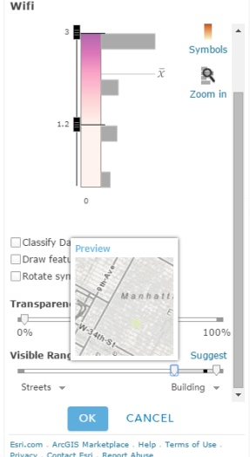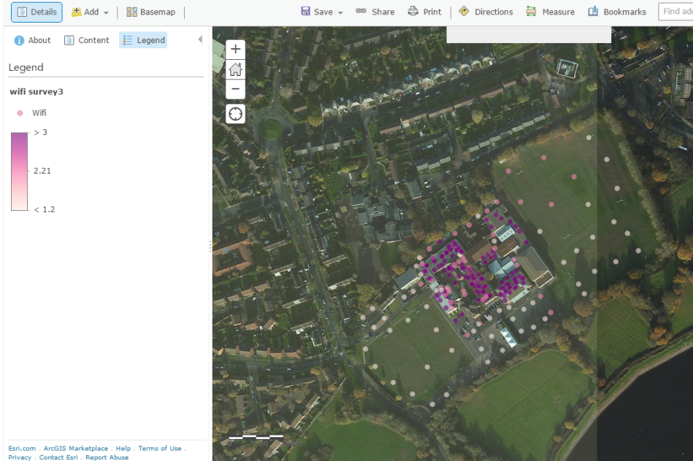
Then go to the bottom of this box to the visible range slider and move the left hand tab to the left so that when you zoom out your data will still be visible. Then click ok.
Then click done and you data will be saved and visible how you want it to be.
Next you are going to carry out some spatial analysis of the data you have collected. This is done by left clicking the little arrow on the layer of the left-hand side and clicking perform analysis.
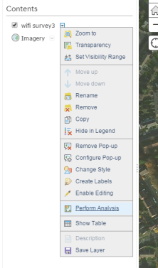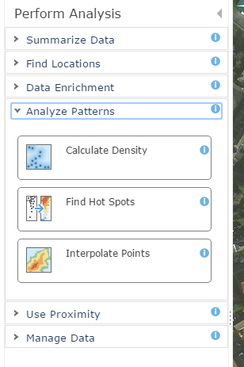
Next click analyse patterns and 3 choices will appear. You are going to use the interpolate points tools. The interpolation tool produces an isoline map of the data a bit like a contour map that looks at all the data points and works out the values in between points to produce a map of all the area not just the point data.
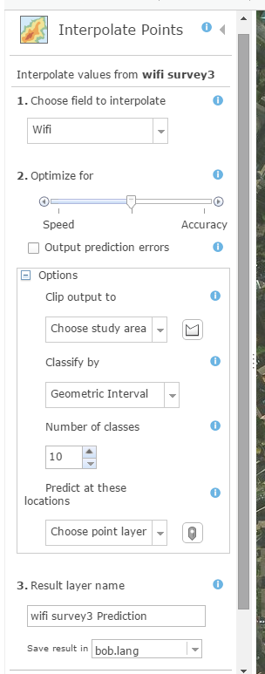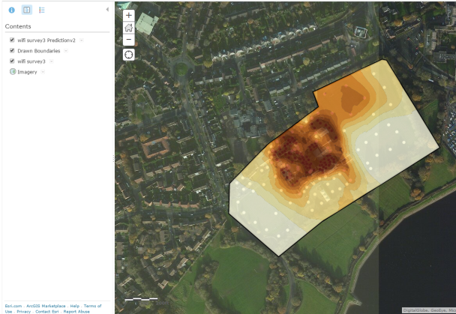
First 1. choose the field to interpolate. Here choose temp for example.
Then 2. Click the options box to create a study area. This is done by clicking on the little icon and then clicking on the map the area you want to map, ie the school grounds. A black border will appear. Then give your result layer a name then click run analysis.
It will take a few moments for the data to be analysed and the layer produced.
Overlaying multiple layers may provide you with the opportunity to see relationships between weather features such as Windspeed vs temperature.

Don’t forget when you screenshot maps you include the legend and the scale bar found in the bottom left-hand corner of the map viewer.

